**E-Commerce Management**

**Date: 29/10/2020**

**Problem Statement:**

**E-Commerce Management system.**

**Java Program to build a restaurant management system. This will be an online restaurant with a wide variety of cuisine like starters, main course, beverages and desserts. The user will be able to place orders on multiple items at a time and then checkout. Separate bills from each section will be calculated. The user will be provided easy payment methods to pay the bill followed by a service feedback.**

**List of Classes in your application domain (8- 10 classes be identified)**

**1. Starters**

**2. Main Course**

**3. Beverages**

**4. Desserts**

**5. Account**

**6. Bill**

**7. Payment**

**8. Feedback**

**Functional requirements of the project:**

1. **This program should systematically display different varieties of cuisine based on user choice.**
2. **Keep a track of all the items ordered by the user.**
3. **Allow the user to make multiple orders from various sections.**
4. **Efficiently display the bill of each category of different cuisine ordered.**
5. **Ask the user to enter his basic credentials like Name Address etc.**
6. **Display the food bill, display the tax applied and finally the total bill to be paid.**
7. **Provide the user with easy methods of payment to pay for the bill.**
8. **Take the user feedback for services and improvements.**

**Rough diagram showing all the classes with their respective data members and member functions :**

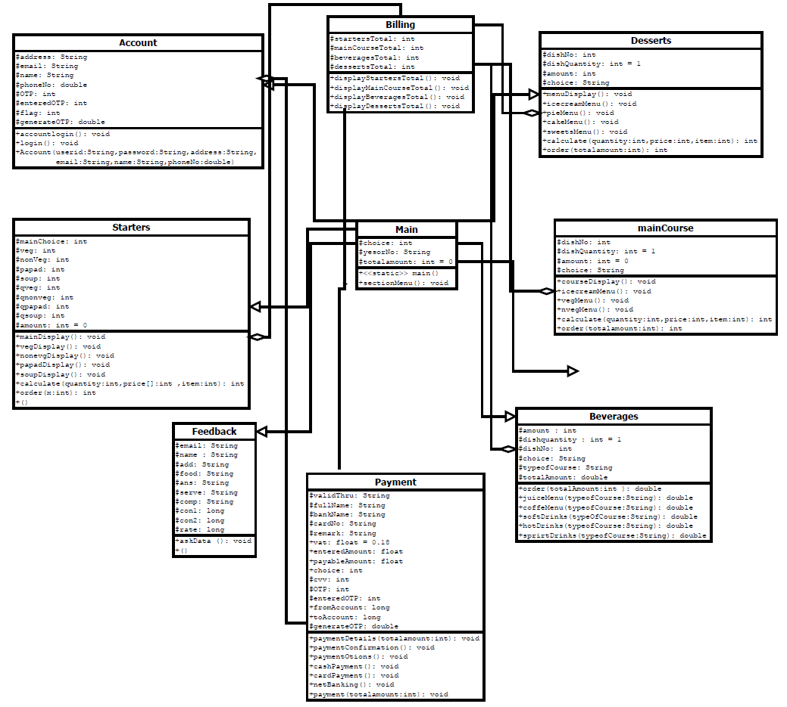

**Group Leader Name and USN:**

**Venkatesh Dhongadi - 2GI19CS175**

**Members:**

**USN NAME**

**2GI19CS185 Vivek Raju Jadhav**

**2GI19CS157 Sumeet P Bafna**

**2GI19CS186 Vivek Valagadde**